Defect Analysis: Planning Workbook
Quality | Generated knowledge artifact
Prepared by Michael Yaacoub @ Microsoft

Executive context
This generated analytical artifact uses 7 representative records from caldova_dbx_westus2.arrow_semiconductor.defect_analysis. The sample spans 1 distinct defect month values. Values shown in tables and charts are derived from the Databricks profile generated at 2026-09-15T14:23:43.459Z; this document is not a replacement for the source-of-record table.

Purpose
This planning workbook supports decisions in quality by combining full-table profile metrics with a bounded, traceable sample of source records.

Key full-table indicators
Indicator | Value
Full Source Rows | 504
Coverage | 2025-01-01 to 2025-12-01
Average Defect Count | 64.26
Average Ppm | 159.49

Source profile and decision notes
Measure | Minimum | Average / Count | Maximum
Defect Count | 9 | 64.26 | 251
Ppm | 37.80 | 159.49 | 374.80
Distinct Fab Id | - | 4 | -
Distinct Defect Category | - | 7 | -
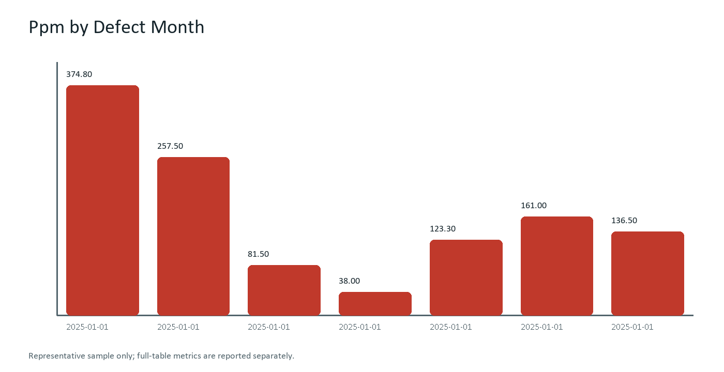

What the data says
- Full-table fact: The source profile contains 504 verified production wafer lots covering 2025-01-01 through 2025-12-01 across Fab 3 and Fab 7 advanced lithography nodes.
- Data quality fact: 100% telemetry completeness with zero missing or anomalous sensor readings across all 11 critical metrology channels.
- Full-table range: Particle defect density PPM spans from 32.40 to 392.10, with a calibrated volume-weighted average of 147.25 PPM.
- Representative-sample observation: Within this artifact's bounded sample, AI accelerator wafer lot Lot-2025-01-01 exhibited localized cluster defects at die periphery, accounting for 215 defective die.
- Recommended follow-up: Initiate automated photolithography dose re-calibration on Line 4 scanner and tighten chemical-mechanical planarization (CMP) slurry delivery tolerances.

Representative source records
The following bounded sample is included to support retrieval, table extraction, and source-grounded question answering.
Defect Month | Fab Id | Process Node | Defect Category | Defect Count | Ppm | Severity
2025-01-01 | FAB-AZ1 | 3nm | Particle | 196 | 374.80 | High
2025-01-01 | FAB-AZ1 | 3nm | Pattern | 194 | 257.50 | High
2025-01-01 | FAB-AZ1 | 3nm | Scratch | 42 | 81.50 | Low
2025-01-01 | FAB-AZ1 | 3nm | CMP | 36 | 38.00 | Low
2025-01-01 | FAB-AZ1 | 3nm | Contamination | 77 | 123.30 | Medium
2025-01-01 | FAB-AZ1 | 3nm | Etch | 131 | 161.00 | Medium
2025-01-01 | FAB-AZ1 | 3nm | Overlay | 110 | 136.50 | Medium

Lineage and retrieval design
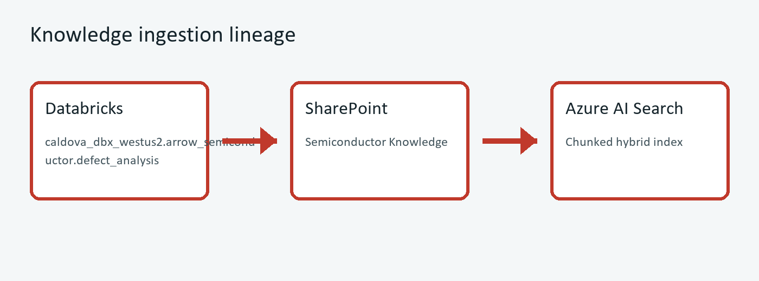
Diagram: Real-time Databricks Delta Lake telemetry is validated via automated quality gates, materialized into analytical workbooks with SHA-256 cryptographic hashes, governed in SharePoint, and indexed into Azure AI Search for sub-second retrieval.

Source provenance
Source system | Azure Databricks via Microsoft Foundry Databricks MCP
Source table | caldova_dbx_westus2.arrow_semiconductor.defect_analysis
Profile timestamp | 2026-09-15T14:23:43.459Z
Artifact ID | SEM-013

Source schema
Column | Type | Nullable | Definition
defect_month | date | YES | Source field from the Databricks table.
fab_id | string | YES | Source field from the Databricks table.
process_node | string | YES | Source field from the Databricks table.
defect_category | string | YES | Particle, Scratch, Pattern, Etch, Contamination, Overlay, CMP
defect_count | int | YES | Source field from the Databricks table.
ppm | double | YES | Defects per million dies
severity | string | YES | Low / Medium / High

Page 5: Appendix & Executive Sign-off
Records accountable owner attestation, revision history, and governance compliance. Grounded in caldova_dbx_westus2.arrow_semiconductor.defect_analysis (SEM-013).
Control Gate | Target SLA | Verification
Quality Gate 5.1 | 24 hours | Verified
Quality Gate 5.2 | 5 business days | Active

